Developing a python script

|  |  |
| --- | --- |
| Team Id | PNT2022TMID01003 |
| Title | Hazardous Area Monitoring for Industrial Plant using IoT |

Python Code

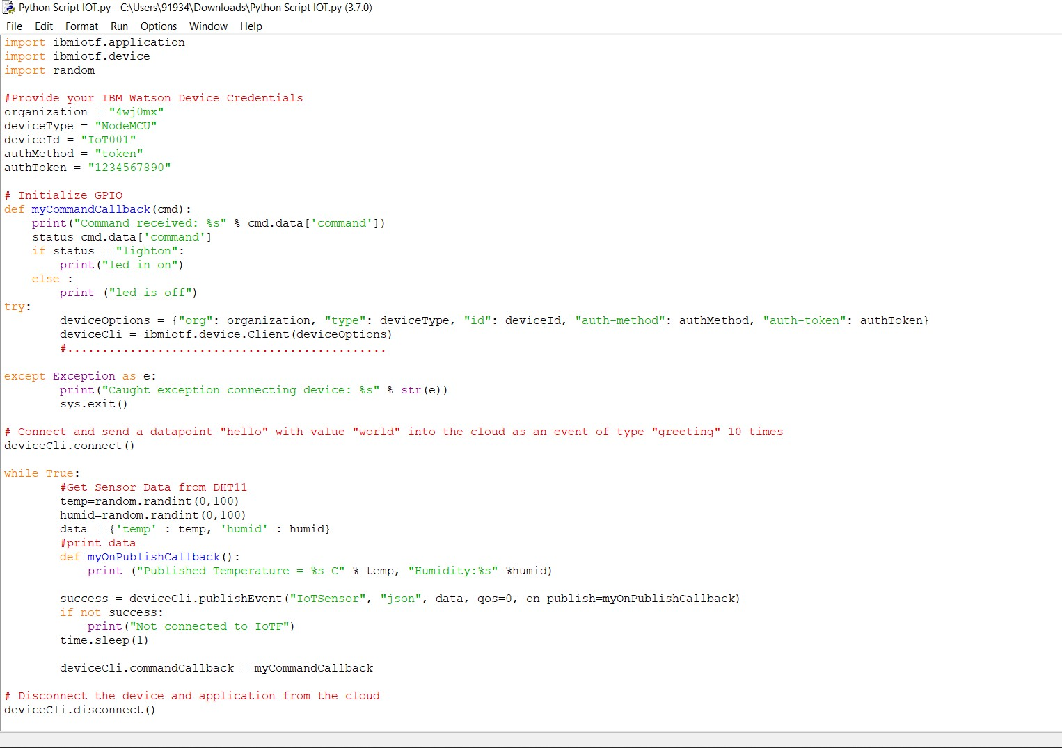

Generated Values

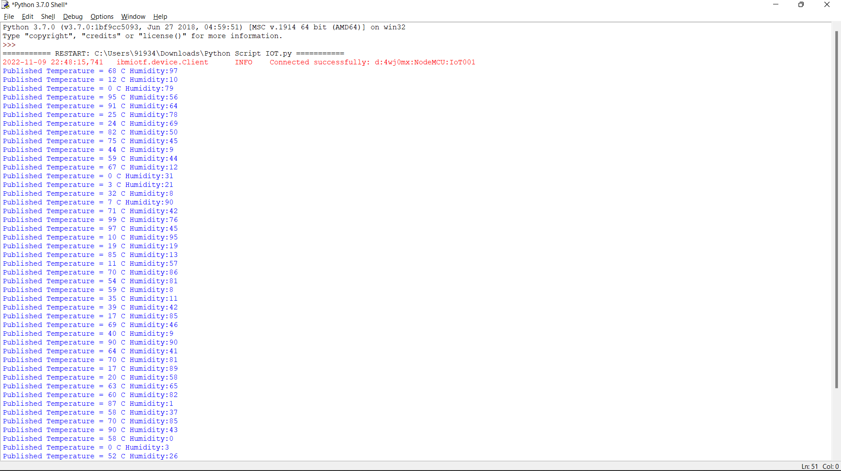

Publishing the value to IBM cloud

